Task on CloudFront & Route 53

- Configure VPC peering in cross regions.
Create 2 vpc’s in different region and send to peering connectionin one VPC
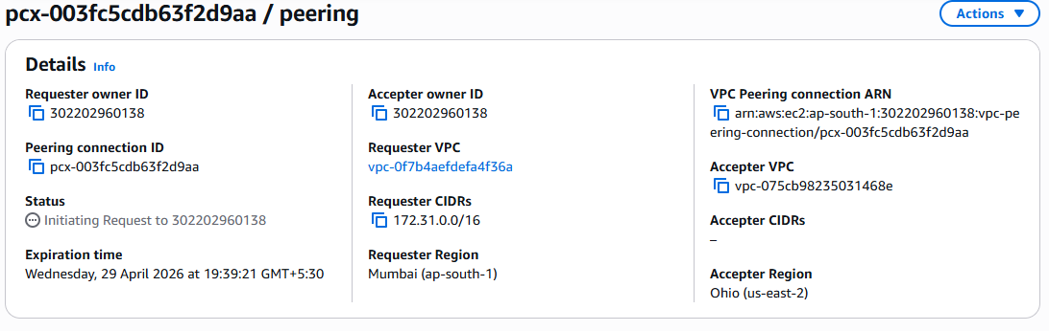
Accepting VPC peering connections from the accepter vpc
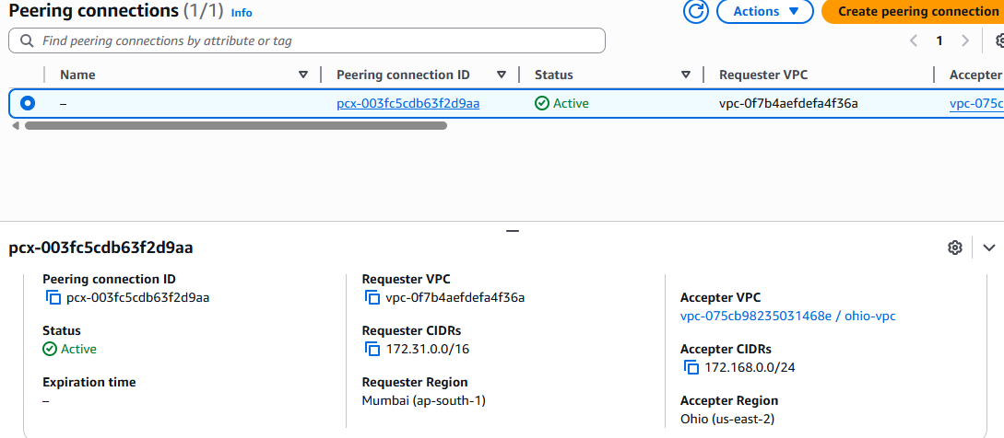

Edit the route table by giving the CIDR range and Now connection is established between two vpc’s
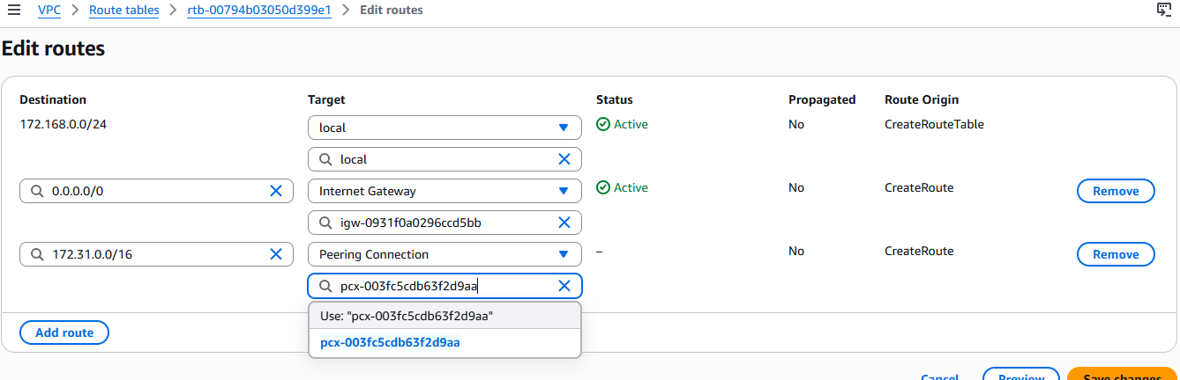

- Purchase one domain from GoDaddy.
Purchased one domain (radharapu.online) in Godaddy.com
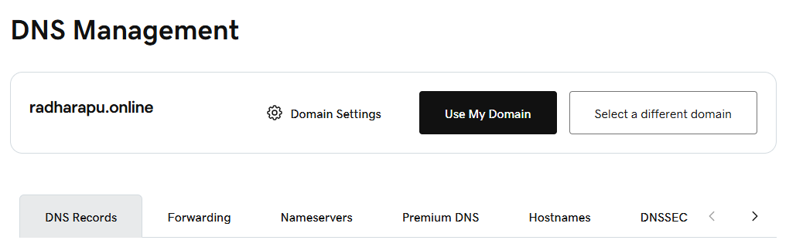

- Deploy static website in S3.
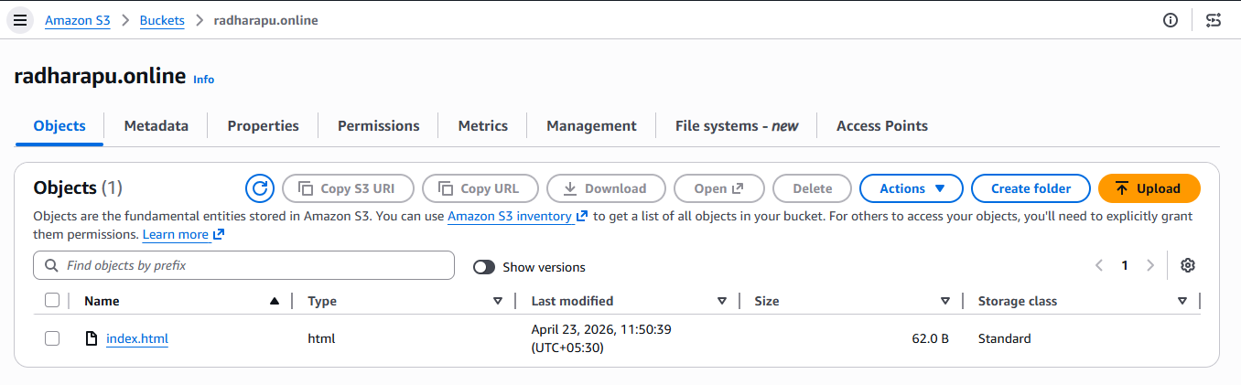
Enabling static website hosting
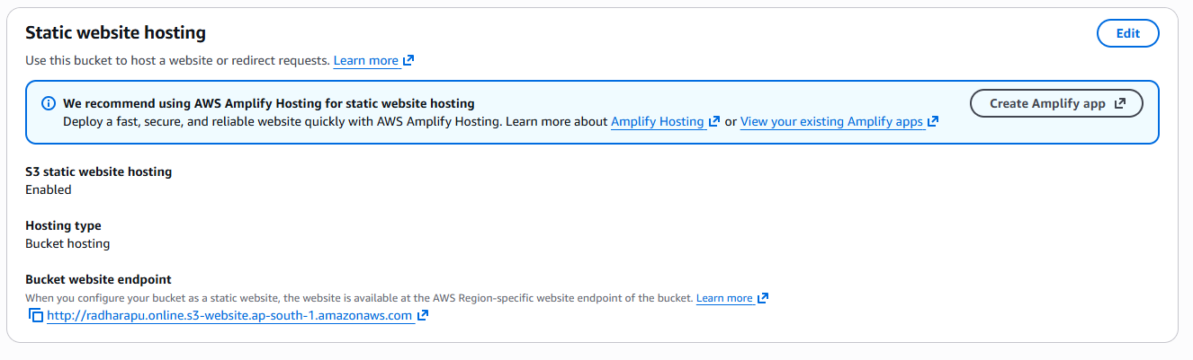
we can check in the browser by using bucket website endpoint
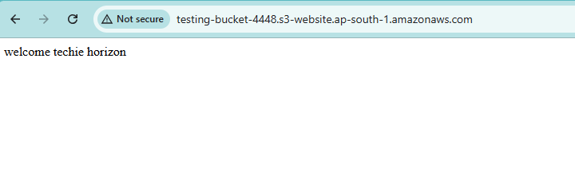

- Create a CDN and attach one SSL certificate.
create cloud front and add domin
by adding domin we want ssl certificate for that, and create one ssl certificate and attach to the cloud front
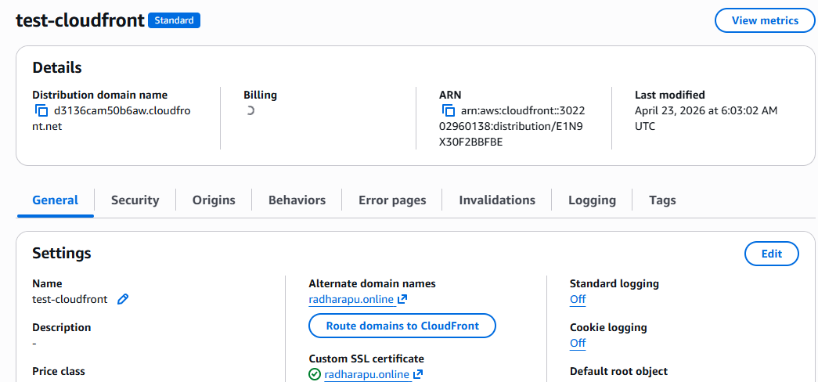
creating certificate
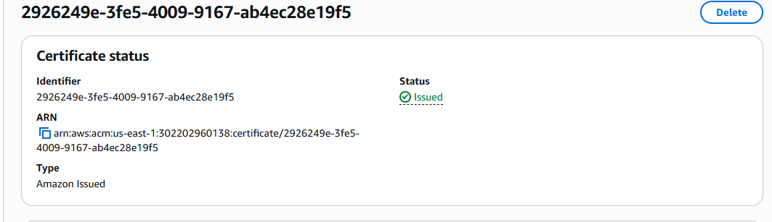

Add domin what your purchasing in godaddy
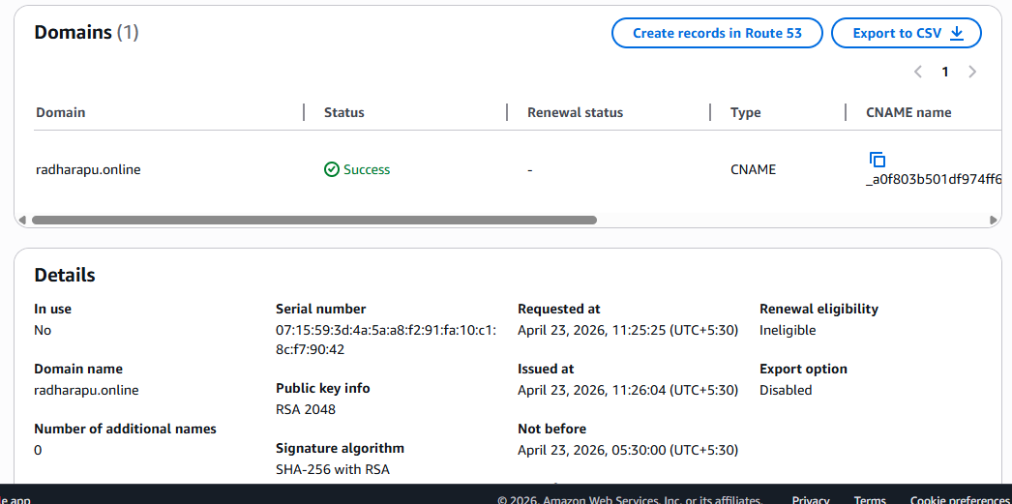

- Create a Route 53 hosted zone and map the domain with the CDN.
Click to route 53
click to hosted zone and create hosted zone
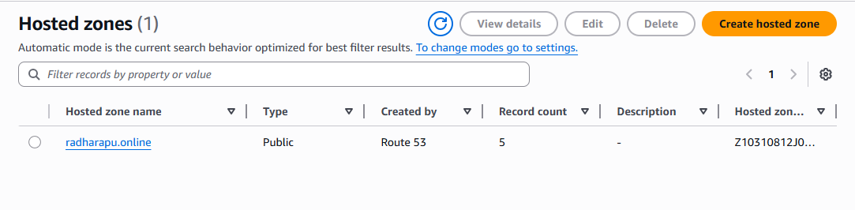

Create record by default we have naming servers
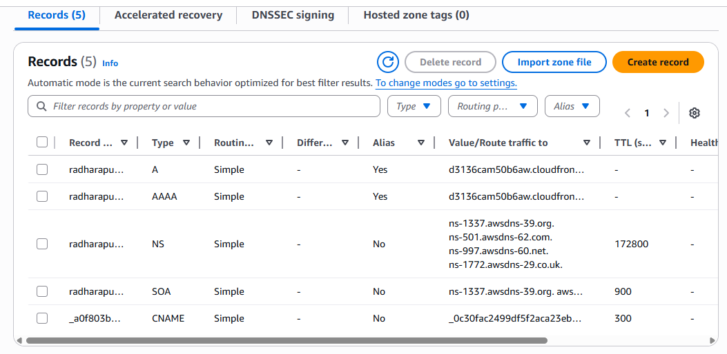
Copy the nameservers and to the godaddy in the nameservers
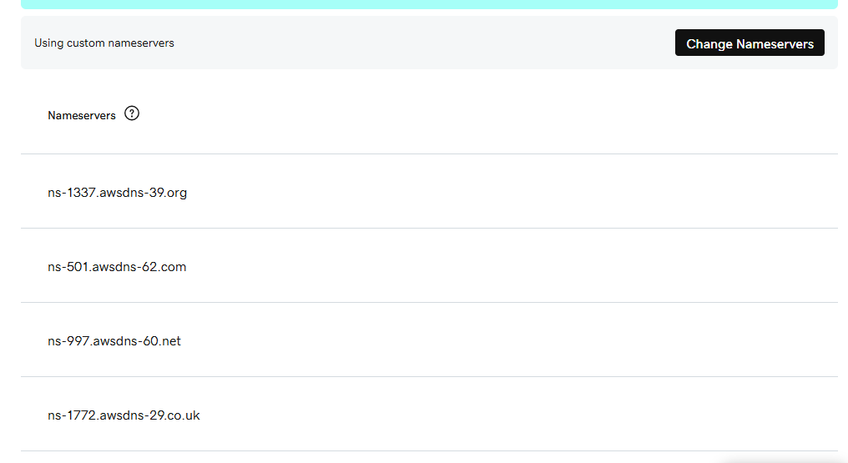

- Update the index.html in the S3 bucket and ensure the updated file is accessible using the domain name.
We can update anything in the index.html file
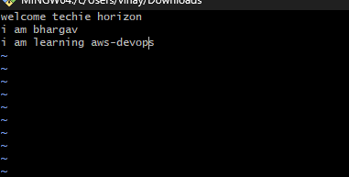
Upload to the my S3 bucket and go to S3 bucket enabling the versions
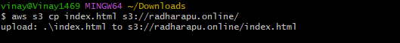
In cloud front we have invalidations create invalidation and giving path like(*/) click to create 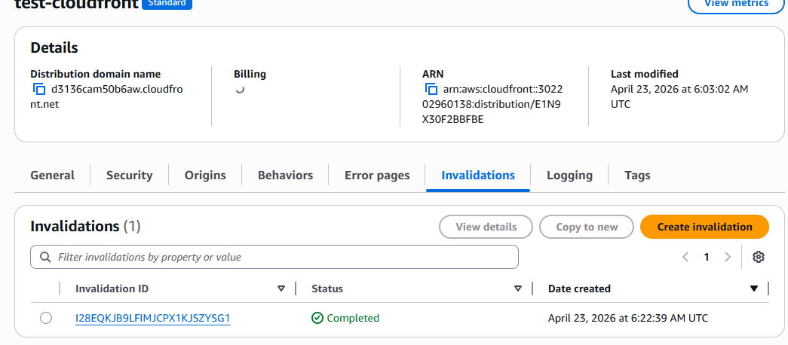

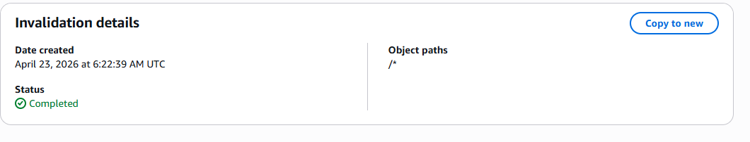

Now check with domin you can saw the changes
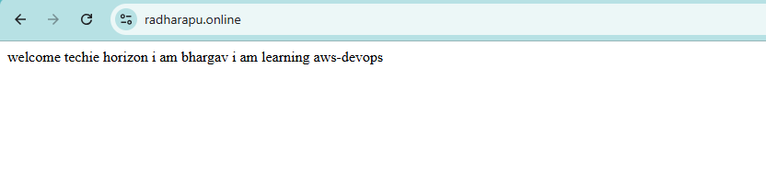
- Share the domain name in Slack to test the connectivity.
radharapu.online

